**Basic Authentication & Authorization 2022**

Reference: <https://github.com/tenPro4/netcore_auth2022>

Youtube playlist: <https://www.youtube.com/watch?v=Fhfvbl_KbWo&list=PLOeFnOV9YBa7dnrjpOG6lMpcyd7Wn7E8V>

# Basic – Cookie Auth

1. Setup

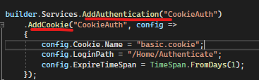

2. Requirement 3 elements:

i. Requirement class

ii. Auth handler

iii. Register requirement and handler





3. Policy builder extend from AuthorizationPolicyBuilder

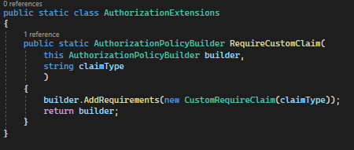

4. IAuthorizationService verify auth with resource(optional)

i. Create auth handler (resource is optional)

ii. Call authorizationService

iii. Register handler and requirement. (pm: operationAuthorizationRequirement is system class,so don’t need register)



5. Customize Auth Attribute (Rank and Level Auth example)

i. Create Requirement and handler

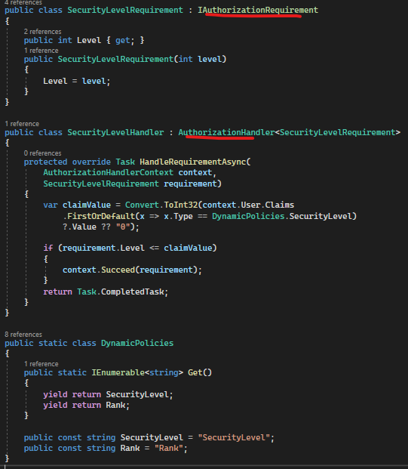

ii. Register handler

iii. Create custom auth attribute

Output

iv. Override Policy Builder to add addition attribute to policy container

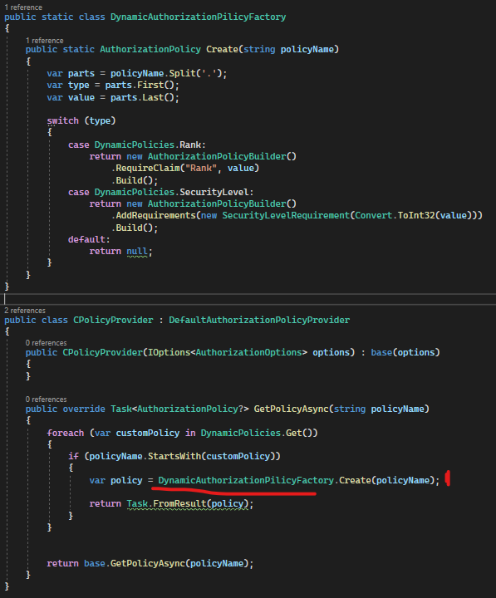

-pm 1: scan all attribute and check policies and register appropriate policy. Rank: check if equal rank value; Securiry Level: Use handler check if user security level is higher or equal specify level.

v. Register policy builder because of override



6. Controller Sign In and sign out. Can specify login and logout path in authentication service registration in program.css.

i. sign in

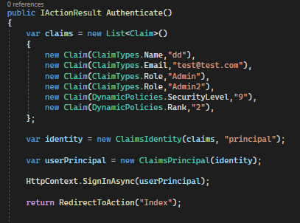

ii. sign out



# Basic – IdentityManager

1. Register AspNEtCore.Identity got few steps and requirement

i. Extend Db object as IdentityDbContext instead of DbContext

ii. Register Identity service and DB context

iii. Configure cookie

2. Login and sign out with signinManager

i. sign in

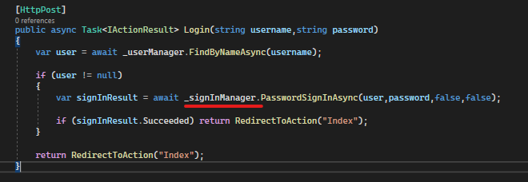

ii. sign out

3. Register with mailkit

i. Install NETCore.MailKit

ii. Configure mail kit



iii.

# Oidc - IdentityServer4

## IdentityServer Setup

1. Create At least two project. One for identity server one for api resource project

2. install IdentityServer4 in identityserver project

3.Create configuration file for identityserver which contain two core elements:

-IdentityResource (identity for identityserver user, not system user)

-ApiScopes (scope contains multi claims)

-ApiResource (API endpoint, can specify apiResource available what apiscopes)

-Client (font-end)

-exp: <https://github.com/tenPro4/netcore_auth2022/blob/main/IdentityServer/Configuration.cs>

4. Register identityserver4 service

i. Extend Db object as IdentityDbContext instead of DbContext

ii. Add services

iii. add middleware



## Api Sources Setup

1. Add auth service

-pm 1: address to identityServer. Audience need exist at ApiResource.

2. Add cors policy



## MVC client setup

1. add auth service. Make auth challenge identity server to get auth

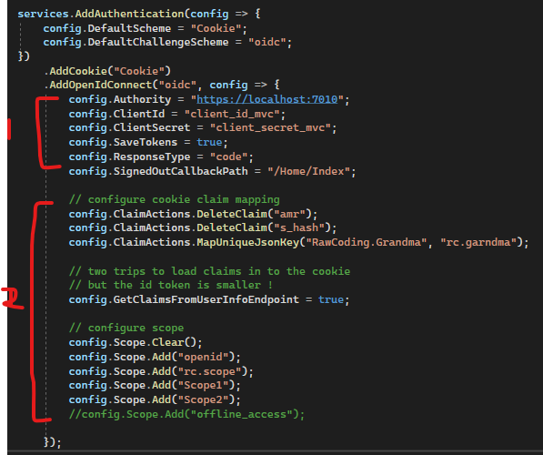

-pm 1: client id and client password is match the identity server configuration

Pm 2: optional.

2. Logout

## Javascript Client

1. import oidc-client library

<script src="https://cdnjs.cloudflare.com/ajax/libs/oidc-client/1.9.1/oidc-client.min.js"></script>

2. Configure client store. All information need exactly same was setup in identityserver like scope, client id ect.

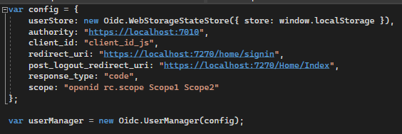

3. sign in and sign out

4. once authorize, do something in moment, like set access token to header

# Register Certificate

1. generate certificate through powershell and paste the file to the project root path. Ref: <https://learn.microsoft.com/en-us/archive/blogs/kaevans/using-powershell-with-certificates>

2.



-filePath: is_cert is file name.

-certificate: generation of certificate will need a password. Provide that password as param.

3. Register certificate.



**IdentityServer4 SQL Server**

1. Include IdentityServer4’s ConfigurationStore and OperationStore to Database

2. Use migration tools to migrating the identityserver4 store tables.

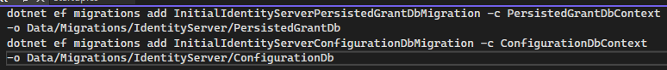

3. Or can use Microsoft.EntityFrameworkCore.Design & Entity Framework Core Tools



4. Migrate database



5. update database to those migrations

